

GLOBODIET
Database management in GloboDiet & Data Entry
Appendix 4
Dietary Exposure Assessment Group (DEX)
International Agency for Research on Cancer (IARC)

Summary:

1. Work & Data Flow between interviewers and coordinator(s)
1.1. Interviewer tasks
1.1.1 Data Collection
1.1.2 Interview Export
1.1.3 Import of the GloboDiet parameter database
1.2. Coordinator tasks
1.2.1 Interview Import
1.2.2 Update of reported Notes
1.2.3 Update of GloboDiet parameter database
1.2.4 Import GloboDiet parameter database
1.2.5 Update of Interviews
1.2.6 Final Export of Interviews
1.2.8 Regular Backup

2. Interview database management
2.1. Restore – Backup Interview Databases (BAK-files)
2.1.1 Add a blank interview database
2.1.2 Restore interview databases
2.1.3 Activation of an interview database
2.1.4 Backup of interview databases
2.1.5 Remove interview databases
2.2. Import – Export Interview Databases (XML-files)
2.2.1 Add a blank interview database
2.2.2 Import of interview databases
2.2.3 Import several Interview Databases in one database
2.2.4 Export of interview databases

3. GloboDiet parameter database management
3.1 Restore GloboDiet database (BAK -file)
3.2 Import GloboDiet database (XML-files)

4. Exported data with GloboDiet & Data Entry
4.1 Import GloboDiet database (XML-files)
4.2 Import GloboDiet database (XML-files)
4.3 Formats of the GloboDiet exported CSV-files
4.4 Example on how to import the GloboDiet CSV-files using SAS program
Database management in GloboDiet & Data Entry

In this manual, the following two functions will be explained:
- Data flow that occurs between the dieticians/interviewers and the coordinators
- Interview database management, which enables the user to handle the collected interview data, such as backing up the interviews or exporting/importing the data in XML-format;
- GloboDiet parameter database management, which enables the user to load the GloboDiet database containing the GloboDiet parameters defined a priori such as food list, food description tables, food quantification tables and others.

Database management functions of the GloboDiet & Data Entry applications are accessible by clicking on the ‘green symbol’ in the top-left corner of the starting screen:
The following menu functions are accessible:
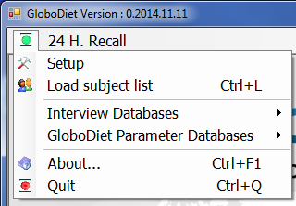

Most of the menus and messages are hard-coded in English to be always accessible even if no database is loaded.
1. Work & Data Flow between interviewers and coordinator(s)

During the data collection phase, we have identified 2 main contributors:
- The interviewers in charge of data collection
- The coordinators in charge of data cleaning including note management and interview update
The following figure represents the different tasks and particularly the data flow between these 2 contributors.
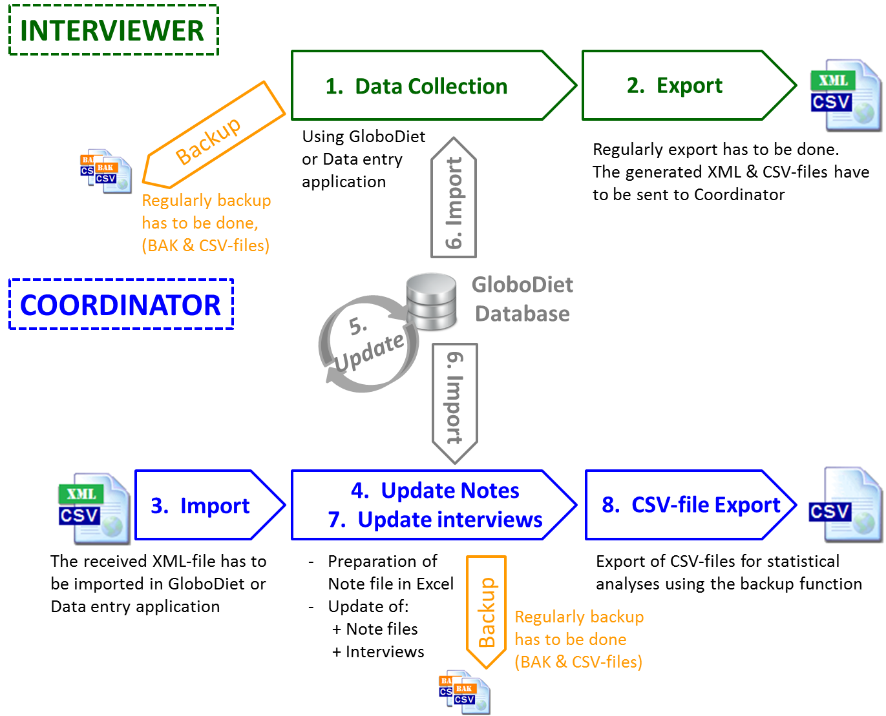
Figure 1: work flow and data flow between an interviewer and a coordinator

1.1. Interviewer tasks

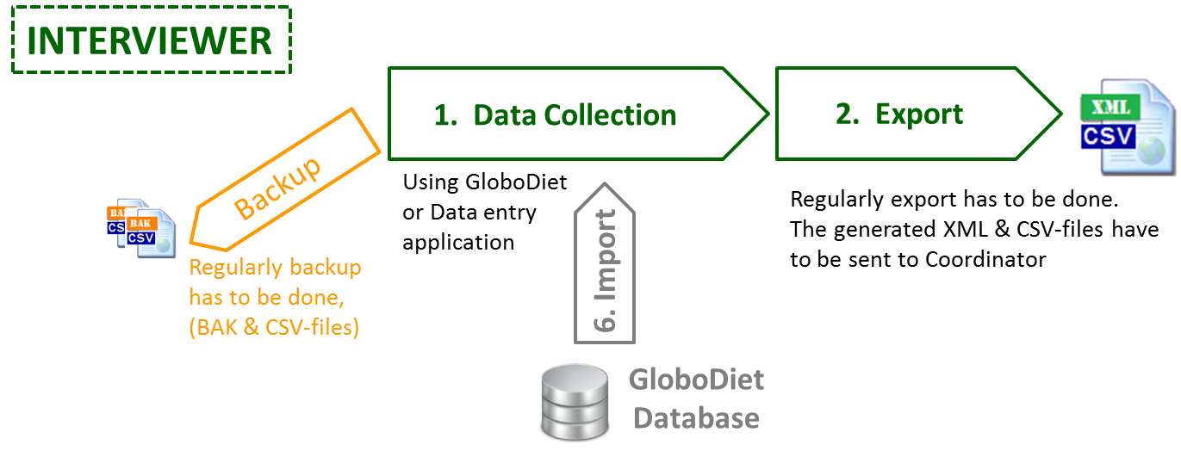

1.1.1 Data Collection – Point 1. in the figure
Interviewers collect the 24h dietary data using GloboDiet and/or Data Entry applications. While doing so, they have to regularly Regularly,BACKUP the interviews using the backup interview function (see point 2.1.4 below) of GloboDiet (or Data Entry) application.
During the backup process BAK & CSV-files are generated. Interviewers have to SAVE these generated BAK-file in, at least,2 different supports (e.g. PC + central server…).
We recommend to the interviewers to back up the interviews at least once or twice a day, depending on the number of collected interviews per day.

1.1.2 Interview Export – Point 2. in the figure
Regularly, Interviewers have to EXPORT the collected interviews using the export interview function (see point 2.2.3 below) of GloboDiet (or Data Entry) application.
During this process XML & CSV-files are generated and the exported interviews will be suppressed (no longer accessible for modification) on the interviewer’s PC.
Immediately, the generated XML-file has to be SAVED and then SENT to the Coordinator.
Interviewers then will continue with a new empty interview database that is usually automatically generated but if needed, a specific function exists to generate it (see point 2.2.1 below).

1.1.3 Import of the GloboDiet parameter database – Point 6. in the figure
Periodically, interviewers will receive an updated GloboDiet parameter database (usually called GloboDiet_xxxx.bak) from the Coordinator which is prepared together with IARC.
The received GloboDiet database has to be RESTORED (meaning that is has to be applied) on each interviewer’s PC using a specific function of GloboDiet (or Data entry) application (see point 3.1 below)

1.2. Coordinator tasks

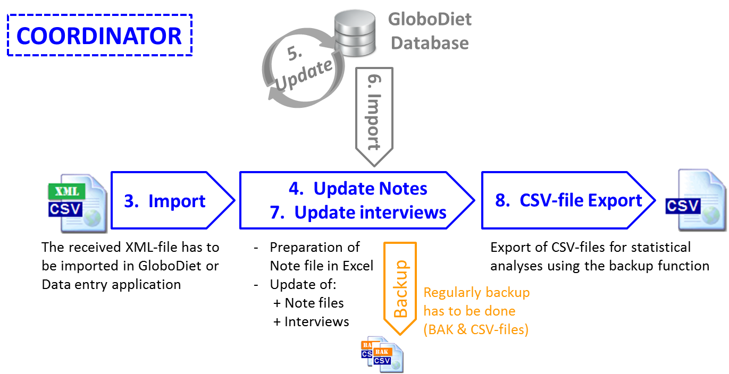

1.2.1 Interview Import – Point 3. in the figure
The interview XML-files received from the Interviewers have to be imported to the Coordinator’s PC using GloboDiet (or Data Entry) application (see point 2.2.2 below).
The new generated interview database has to be saved using the backup interview function (see point 2.1.4 below) of GloboDiet (or Data Entry) application. BAK & CSV-files are generated.
Remarks:
- For the moment, GloboDiet (or Data Entry) application generates as many interview databases as the XML-files received (from the interviewers).
- A new function allowing merging in one interview database several received XML-files is under development.

1.2.2 Update of reported Notes – Point 4. in the figure
All the generated Notes.csv files can be imported into one Excel file and IARC recommends centralizing all these Note files in a unique Excel file (see below point 4.1 & 4.2).
Depending on the Note type, content, comment and depending on the rules defined at project level, the reported notes should be commented on and their status updated accordingly during data cleaning.
Example 1:
A reported note with “General” type (coded G) and a comment saying “the subject is very enthusiastic” will probably move from Status ‘New’ to Status “Nothing to do” and a new comment ‘done’ can be added.
- See guideline Data cleaning protocol_GD_xxxx.docx

1.2.3 Update of GloboDiet parameter database – Point 5. in the figure
Based on the reported notes, some items will have to be reviewed or added in the parameters database (e.g. add new foods, change maximum values, etc…)
With IARC’s help, a new GloboDiet database has to be generated (e.g. using food update forms FUF, recipe update forms RUF, changing values in food maximum file…)

Example 2:
For a reported note with “New food” type (coded NEW_F) and a comment saying “new food – not found in the proposed food list”, the coordinator will have to see first, if the food is effectively missing or not:
- If the food is available in the food list, the notes status will be changed to “Ongoing” and a comment added that the food has to be selected from the food list to replace this ‘new food’.
- If the food is missing in the food list:
  - The notes status will be changed to “Ongoing, database needed”,
  - The new food should be added to the food list by the Coordinator using the food update form (FUF) and sent to IARC who will then provide the Coordinator with a new GloboDiet parameter database including this new food.
- See guideline Data cleaning protocol_GD_xxxx.docx
- See guideline Maintenance

1.2.4 Import GloboDiet parameter database – Point 6. in the figure
Once, the Coordinator has sent to IARC all the items to be updated or added, IARC will prepare an updated GloboDiet database that will be sent to the Coordinator.
This new GloboDiet database will have to be restored in the GloboDiet (or Data entry) application on the coordinator’s PC (see point 3.1 below).
This new database has also to be sent to the Interviewers to be also restored on each of their PCs (see point 3.1 below).
- After having imported the new release of GloboDiet database, it is important to run the Recompute ((a function embedded into the application) on the available interview databases. This is done by simply backing-up all of them (see point 1.2.8 below)

1.2.5 Update of Interviews – Point 7. in the figure
Regarding the reported Notes and attached status available in the Excel file, the Coordinator can open and update the interviews that need it using GloboDiet (or Data entry) application.
To found in which GloboDiet interview databases, the interview is available, you can use the name available in the column called “Database name” of the Excel Note file.
Remark:
Regularly, the updated interview database should be saved regularly using the backup interview function (see point 2.1.4 below) of GloboDiet (or Data Entry) application. BAK & CSV-files are generated and have to be saved in a different support.

1.2.6 Final Export of Interviews – Point 8. in the figure
Once an interview database has been updated or when you need it, the Coordinator can export the interviews in CSV-files using the backup interview function (see point 2.1.4 below) of GloboDiet (or Data Entry) application.
The 5 generated CSV-files are:
- InterviewSetName_INTGI_date.CSV: contains general information about the subjects and the recalls/records
- InterviewSetName.INTERV_date.CSV: contains the reported foods/recipes/ingredients/supplements with detailed consumption descriptions
- InterviewSetName.INTER_QT_date.CSV: contains two specific quantification methods, namely photo and shape methods as reported
- InterviewSetName.INTNUT_date.CSV: energy and macronutrient intakes per reported food (the one used for checks in the system after the recall)
- InterviewSetName.NOTES_date.CSV: reported notes generated during the interview/data entry
Although the most important 24-HDR information is included in the INTERV & INTER_QT file, also the information included in the INTGI and the INTNUT files can be relevant for further data cleaning procedures performed after data export.
The most efficient way in performing data cleaning after data export is by merging all the variables included in the INTERV, INTGI and INTNUT files together into one single data-file. Such merge procedure can be executed automatically via statistical software packages such as SPSS, SAS, STATA or R (R is freely available/downloadable via the internet).

- See guideline Appendix 6 Export_guideline_v4.docx for the format of the 5 generated CSV-files
- See Appendix 7 Example_SAS_programs_GloboDiet_Export.docx for how to transform the 5 CSV- files in SAS databases.

1.2.8 Regular Backup – Orange point in the figure
Regularly, the updated interview database has to be saved using the backup interview function (see point 2.1.4 below) of GloboDiet (or Data Entry) application.
During the Back-up process, the Recompute (a function embedded into the application) of the collected interviews also runs and is important when any parameters, particularly coefficient values, have been changed. The Recompute reruns all the algorithms attached to each reported foods/recipes using all the parameters available in the GloboDiet databases. For this reason, we recommend to backup all the interview databases at the reception of a new/updated GloboDiet database.
BAK & CSV-files are generated and have to be saved on a different support (PC, external drive…).

2. Interview database management
In the sub-menu of the Interview Database management, two menu functions are accessible:
- « Restore – Backup Databases »
- « Import – Export Databases »
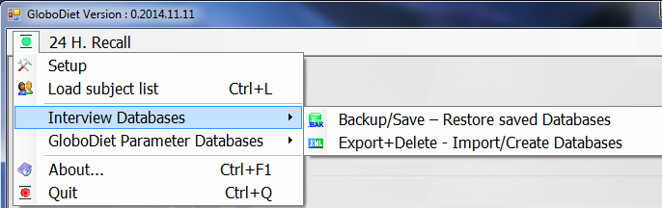

2.1. Restore – Backup Interview Databases (BAK-files)

If you click on « Restore – Backup Databases », the following pop-up appears:
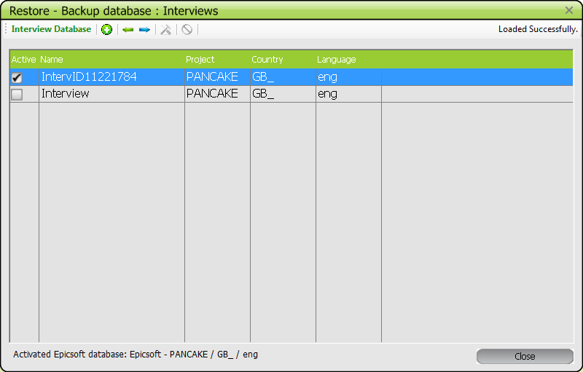
The active database is identified by the selected check box to the left of the database name.

To select the different functions available on this screen, the user can either select them in the tool bar at the top of the screen or use the right mouse button:
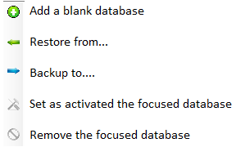

2.1.1 Add a blank interview database
With the function « Add a blank database », the user can generate a new and empty interview database. A pop-up is displayed asking to assign a name for this new interview database.
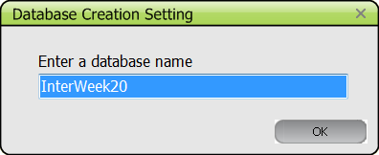
Then, you can activate it and all the new interviews will be stored in this database.
An empty interview database can be generated for each subject or dietician or by a defined period (each day, week, 2 weeks…), etc…

2.1.2 Restore of interview databases
The function “Restore from…” restores a previously saved interview database from a BAK-file.
The main reasons to restore an interview database (BAK-file) are:
- In case of a PC crash, in such caseyou will want to restore the completed interviews on another PC.
- As a coordinator (as an example), you may want to go back to/restore different backup sets of interviews. In this case it is strongly recommended to use different interview database names within the GloboDiet application (e.g. InterviewDietA, InterviewDietB….)
To restore a selected set of interviews click the icon (in the tool bar or using the right mouse button).
A pop-up is displayed asking to do the following:
- enter/define an interview database name (e.g. InterviewDietA) that will be used by GloboDiet (note : do not use space or special characters to enter this name),
- Select a BAK-file to be restored within folders using the browse button.
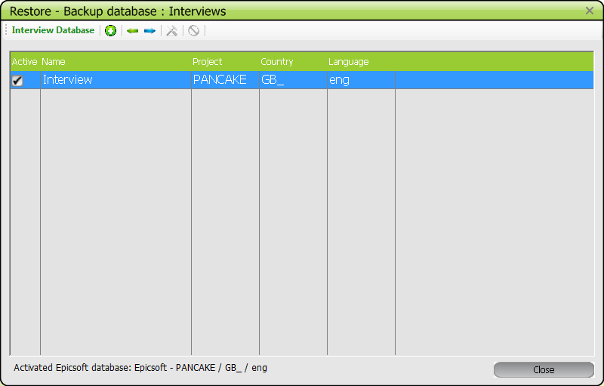
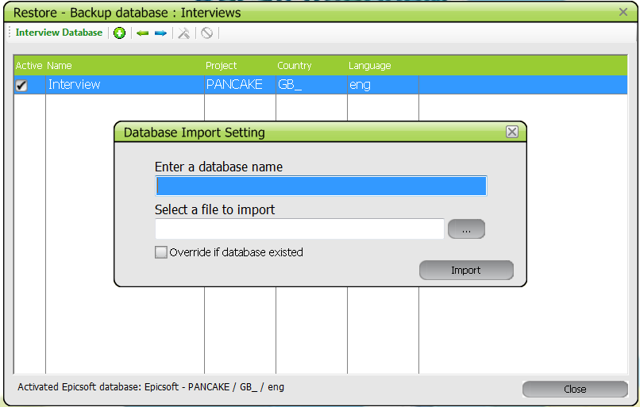

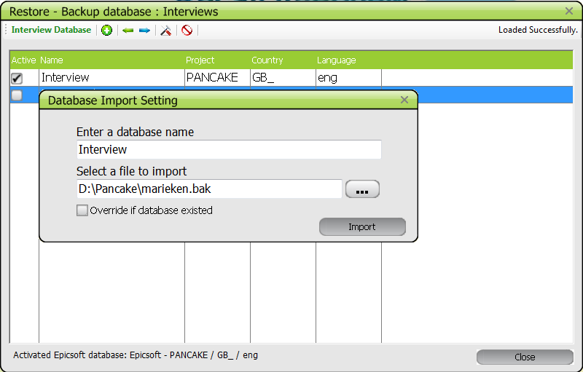
If the interview database name already exists, and you want to override it, you will have to click on the “Override of database exists” button; else the following warning message is displayed. At this point, you can still click on “x” to cancel the override and enter a different name.
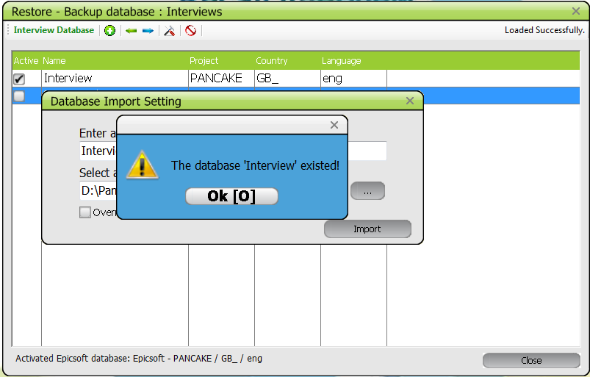

Once the correct information is entered, you can select the Import button.
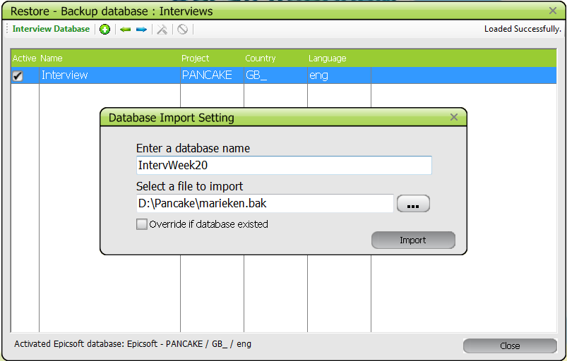

The import ends with the following message:
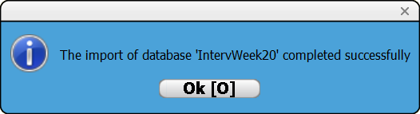

The Database management screen now contains the database.

2.1.3 Activation of an interview database
In order to use an interview database you must first activate it. A check mark next to a database indicates which database is currently active (see below). Choose the Interview database to activate, which will be used by GloboDiet or the Data Entry application, by placing the cursor/left-clicking on the corresponding line (line in blue).
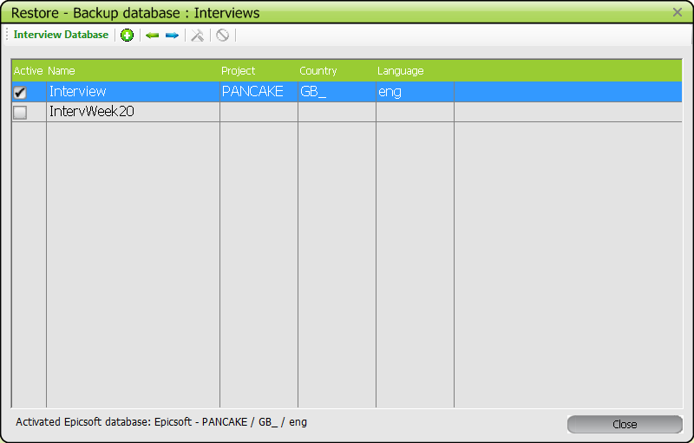

Then select the “set as an active Database” function using the button
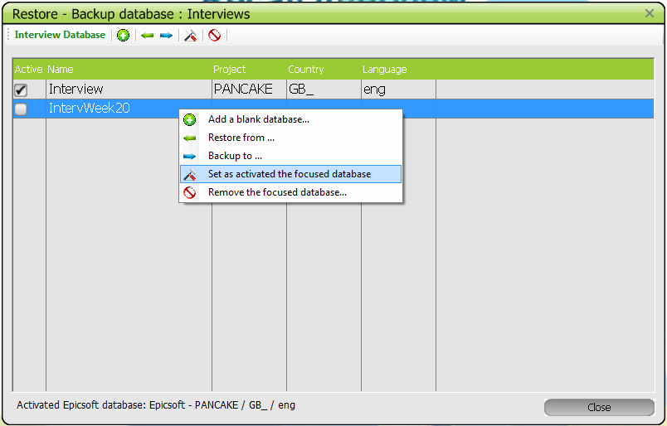
Then confirm your selection by choosing the option ‘Yes’ and the GloboDiet application (or Data Entry application) will be closed and re-opened.

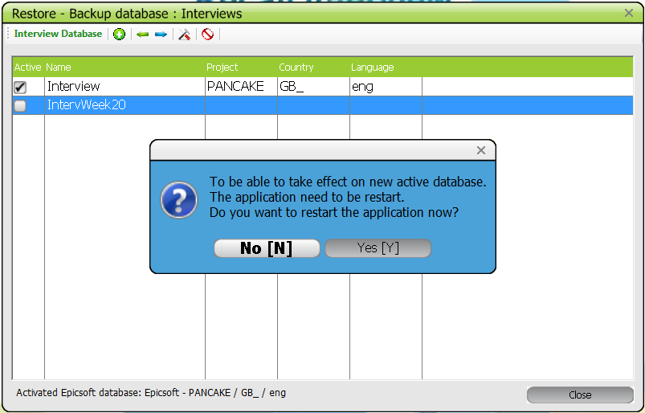
Once the application reopens, the previously selected interview database (called IntervWeek20 in the above example) has become the active one. Indeed, if you select again the interview database management you will see a check mark next to it:
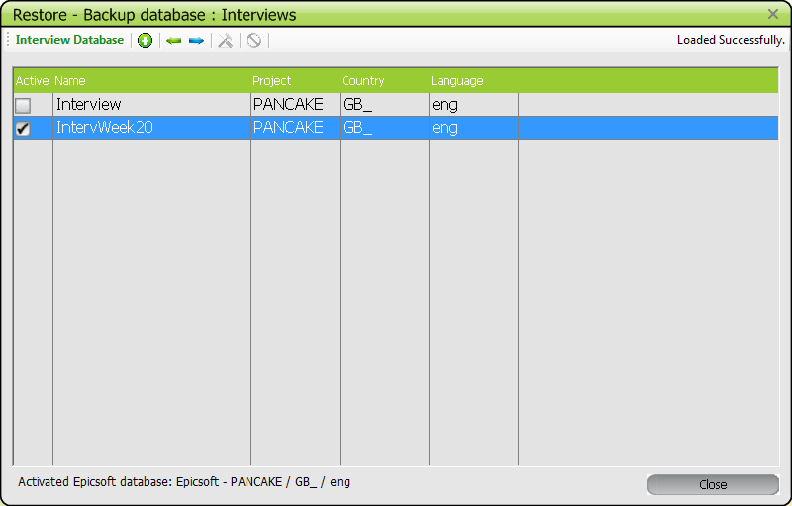

2.1.4 Backup of interview databases
The “Backup interviews” function allows saving the interviews done with GloboDiet in another format and support drive/system (alternative to the PC drive where the GloboDiet application is run). This action needs to be done by the interviewer very frequently (at least weekly if not daily) in order to have back-up copies of the completed interviews in case of a PC crash/failure or the PC gets stolen. The generated BAK-file can be restored on another PC using the “Restore interview” function, in order to not lose data. The interviews would be available then for editing using GloboDiet application.

The function « Backup to… », generates a BAK-file that should be stored on at least 2 different supports (e.g. in a special directory on the PC and on an external support such as hard disk, USB-key) and also 5 CSV-files containing all the interviews available in the selected interview database. The CSV-files are available but just for information.
You can export the selected set of interviews by clicking on the icon (in the tool bar or using the right mouse button).
A pop-up is displayed allowing to select a folder in which to save the set of interviews. A BAK-file will be generated and copied to this folder. This backup file name is the same as the selected database but can also be changed by the user. The user has also the option to attach the current date to the BAK-file name by activating the designated field. The 5 CSV-files are generated at the same time as the BAK-file and are:
- INTGI: File containing general information on subject and on recall/record.
- NOTES: File containing reported notes during the interview/data entry.
- INTERV: File containing reported foods/recipes/ingredients/supplements with detailed consumption descriptions.
- INTERV_QT: File containing two specific quantification methods that are photo and shape methods for which several servings can be selected.
Note: This file is not generated if these two methods have not been selected during the interview/data entry.
- INTNUT: File containing energy and macro-nutrient intakes per reported food. The available components are energy, proteins, fats, carbohydrates, alcohol and water.
Please, find in annex, the content of these 5 CSV-files.
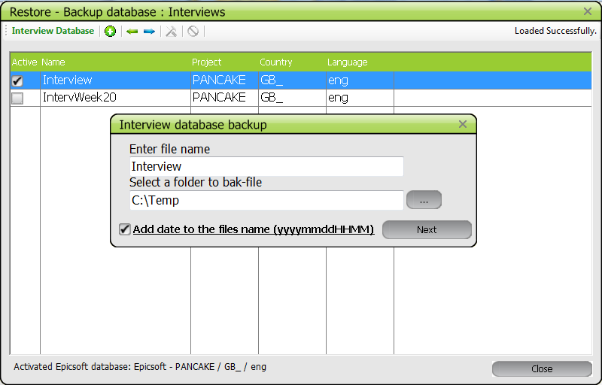
Once the generation of the backup and CSV-files is completed, the following pop-up is displayed:
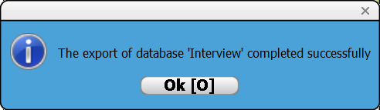
Then the user can rename this file on her/his PC and save it also on other different supports.

Notes:
- The saved interviews are not deleted and still active as Interview database used by the GloboDiet application. That means that the new interviews will be added in the active Interview database. See section 1.1.5 for removing interview sets.
- It is strongly recommended to back-up the completed interviews as frequently as possible, in accordance with the study protocol (e.g. every day, half a day…).

2.1.5 Remove of interview databases
You can remove the selected set of interviews by placing the cursor/left-clicking on the corresponding database and by clicking on the icon (in the tool bar or using the right mouse button).
Of course, this option should be selected only if a save (export or backup) of the Interview database has already been performed before (see section 1.1.4). The last backup date can be checked on the screen pop-up before confirming this action.
A confirmation message is displayed and you select ‘Yes’ to accept.
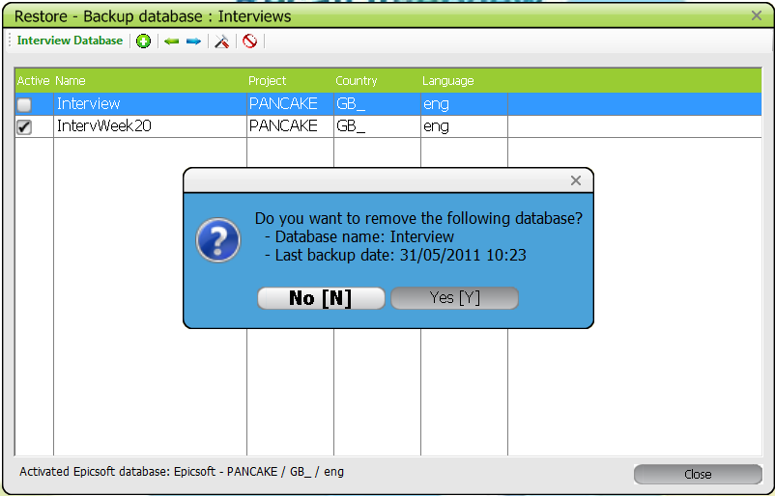
The removal ends with the following message:
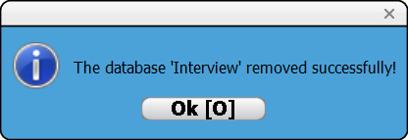
The interview database is not available in the interview database list.
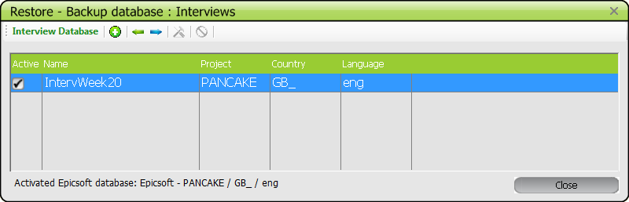

2.2. Import – Export Interview Databases (XML-files)

The “Export Interviews” function allows exporting interviews done with GloboDiet in order to load them in the Coordinator’s PC. After the export, the exported interviews will no longer be available in the GloboDiet application database so cannot be edited using GloboDiet. The export of an interview database automatically creates a blank database in the GloboDiet application, for storage of the next set of interviews on the PC.
The export is normally done by the interviewers once a series of interviews has been completed and a new series is about to start (e.g. every week, every month or another interview period as defined by the project coordinators…).
During the export, an XML-file and 5 CSV-files are generated. The CSV-files are available for information purposes such as for performing some preliminary analysis or quality checks (e.g. you can read them using Excel spreadsheet application to get an idea about the list of available interviews, notes…).
The XML-file can be (re-)loaded in GloboDiet application using the “Import interviews” function.

In the GloboDiet application, if you click on « Import – Export Databases », the following window appears:
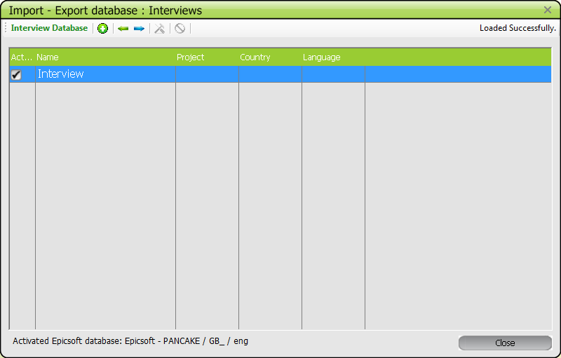

The active database is identified by the selected check box to the left of the database name.
To select the different functions available in this screen, the user can either select them from the tool bar or use the right mouse button:
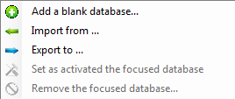

The steps to import/export an interview database are similar to the steps described under 1.1. The difference in selecting « Import – Export Databases » as compared to « Restore – Backup Databases » is that using the Import/Export function two types of files are created, a BAK-file and in addition an XML-file, and the exported database is suppressed (no longer available until imported) from GloboDiet application.

2.2.1 Add a blank interview database
At times, it may be necessary to add a blank interview database before starting the fieldwork in order to separate the test interviews from the real fieldwork interviews. This is particularly relevant when some training interviews were performed on the PC using the GloboDiet application and no export (see above) was performed to clear those set of test interviews from the GloboDiet application and the PC.

With the function « Add a blank database » or by clicking the icon, the user can generate a new and empty interview database. A pop-up is displayed asking to input the name of this new interview database.

2.2.2 Import of interview databases
The function “Import from…” imports an XML-file.
To import a selected set of interviews click the icon (in the tool bar or using the right mouse button).
A pop-up is displayed allowing to:
- Enter/define a database name (e.g. IntervWeek18) that will be used by GloboDiet application (note : do not use space or special characters to enter this name),
- Select the desired XML-file within folders using the browse button.
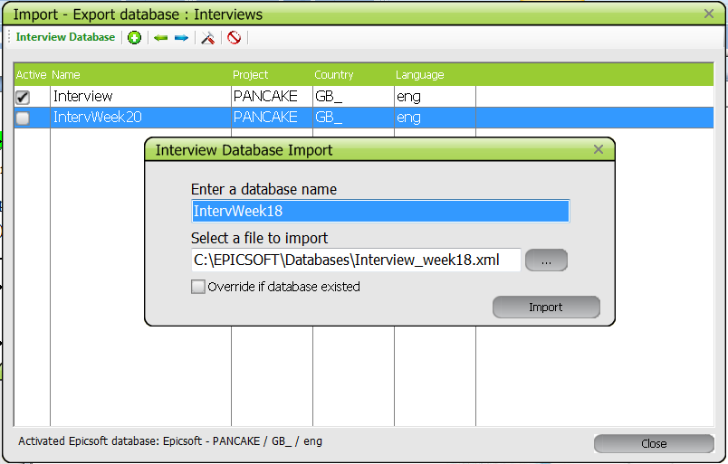

The load ends with the following message:
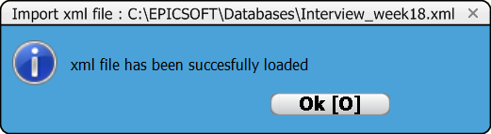
Then the window « Import – Export database: Interviews » is displayed containing the imported database.
Note that the active interview database is not changed. The user may activate a different interview database if needed (see point 1.1.3).
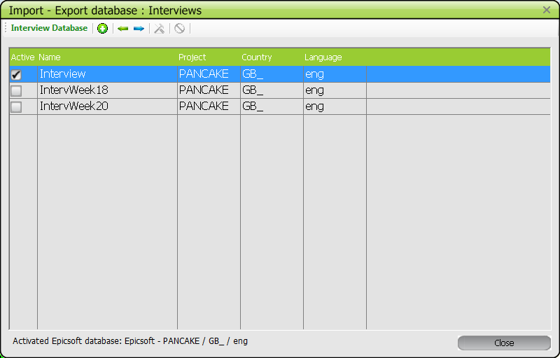

    - Import several Interview Databases in one database

The function “Batch-Import from…” allows importing several XML-files into one Interview database in the GloboDiet application.
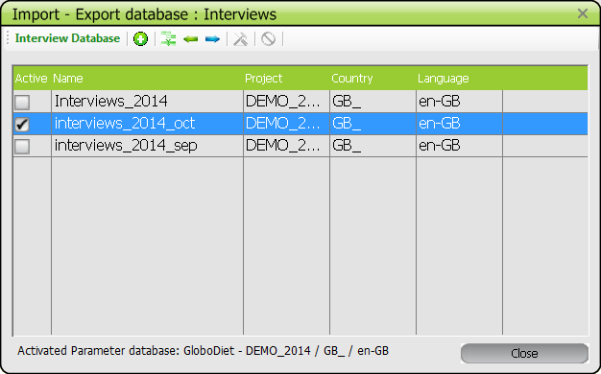
To import several selected xml-files of interviews click the icon (in the tool bar or using the right mouse button).
A pop-up is displayed allowing to:
- Enter/define a database name (e.g. Interverviews_2014_nov) that will be used by SQL server 2008 express to merge several XML-files (note: do not use space or special characters to enter this name).
If you use an existing database name, the imported interviews will be added to this existing interview database.
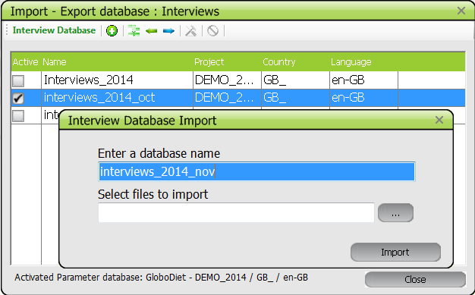

- Select the desired XML-files to be imported (using Shift+arrow/Ctrl+click) within the same folder.
- The XML-files to be merged have to be moved into one folder before the import
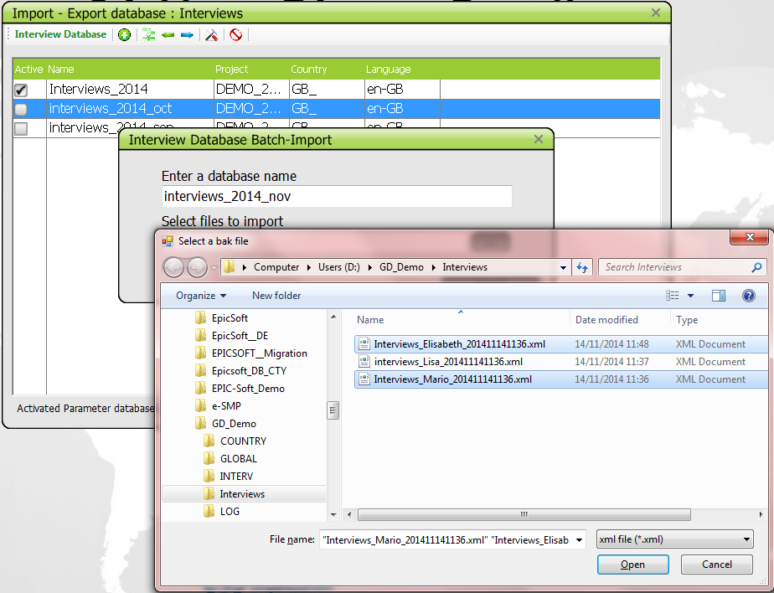

Once the information is filled, select the Import button,
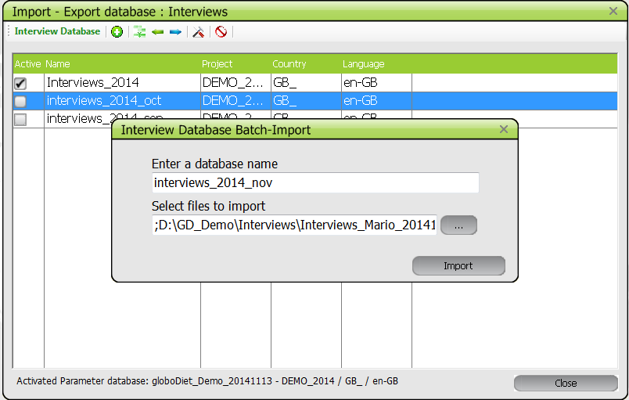
A pop-up displaying the list of managed interviews is available. The information on the managed interviews (imported xml-file, ID code, recall date, interview version) as well information on the import process (error code & comment) is displayed.
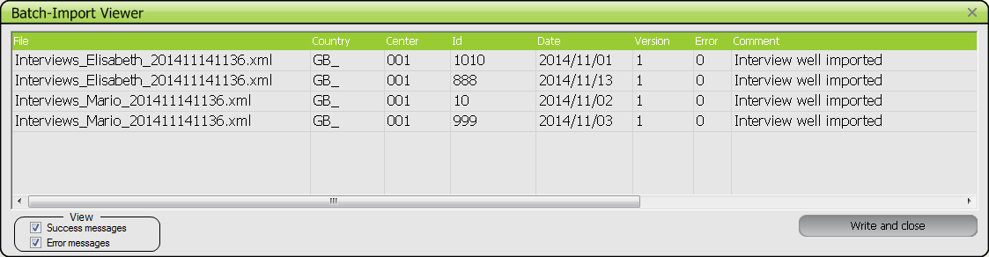
You can use the View buttons to display only the “success” messages or only the “Error” ones or both (default).
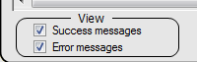
Example with only success messages
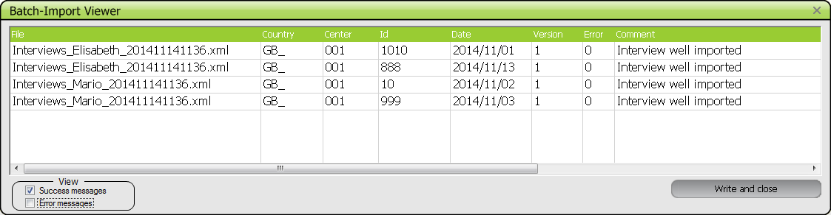
Example with only error messages
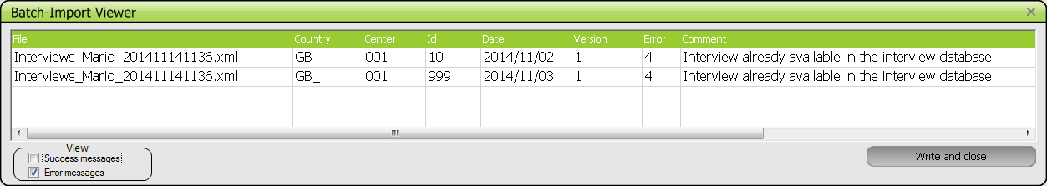

The error codes and messages are:
- ‘0 Interview well imported’ → The interview has been imported without any errors
- ‘1 Error on Project code’ → The project code defined in the imported xml-file is incompatible with the project available in the active GloboDiet database
- ‘2 Error on country’ → The Country code defined in the imported xml-file is incompatible with the Country available in the active GloboDiet database
- ‘3 Error on language code’ → The language defined in the imported xml-file is incompatible with the language available in the active GloboDiet database
- ‘4 Interview already available in the interview database’ → As GloboDiet application cannot erase any interviews or delete/replace one interview by another one, the import is refused generating this error code.
- ‘5 This interview has a version number <= to the one available in the database’ → the interview to be imported is an older version than the one available in the merged database. As GloboDiet application cannot delete and replace an interview by an oldest one or the same one, the import is refused generating this error code.
- ‘6 Error in the xml-file format’ → the read xml-file does not have a compatible format with GloboDiet application.

To exit the pop-up, you have to click on the “Write and Closed” button. This action is followed by the display of 2 pop-ups, one for saving the returned comments in a log file and the second for saving the rejected interviews in an xml-file. This last pop-up is displayed only if rejected interviews are available.
- Saving the returned comments in a log-file:
A ‘Save log file’ pop-up is displayed.
By default the name of the merged interview database is proposed as log-file name and clicking on the check box “add date to the file”, the date and hour of the day will be attached to the log-file name.
Using the browse button, you can select a folder to put this log-file.
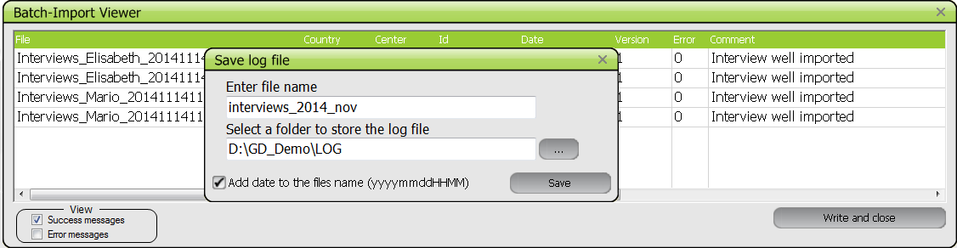
The content of the log-file is the same as the Multi-import window with:
  - A header specifying information on the target database and on imported ones.
  - A body displaying the list of managed interviews with information on interviews and on the import process. This part uses the pipe (‘|’) character as a delimiter to easily import it in Excel if necessary.
Example
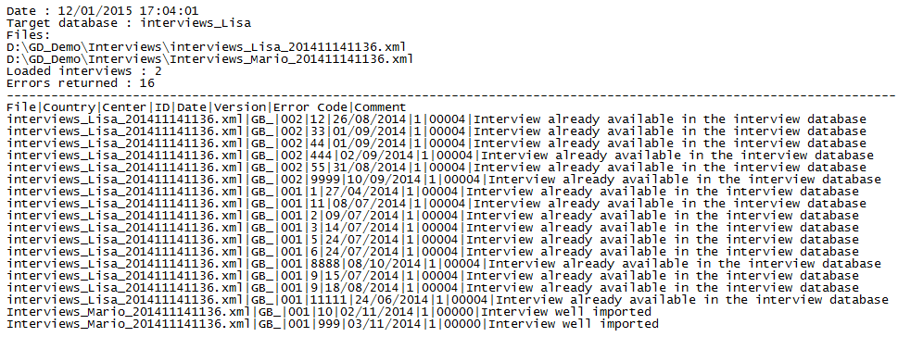
- Save of the rejected interviews in a XML-file:
‘Rejected Interviews’ pop-up is displayed only if rejected interviews are available.
By default the name of the merged interview database is proposed as XML-file name but you can change it. Clicking on the check box “add date to the file”, the date and hour of the day will be attached to the XML-file name and by default, this check box is activated.
Using the browse button, you can select a folder to put this XML-file of rejected interviews.
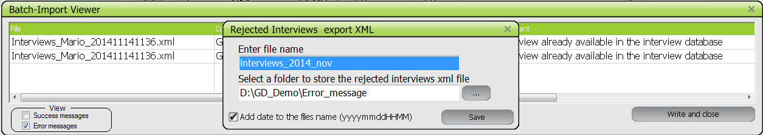

Once these actions are done, the ‘Import-Export Interviews’ window is displayed and you can activate the created/updated database using the “set as activated” function.
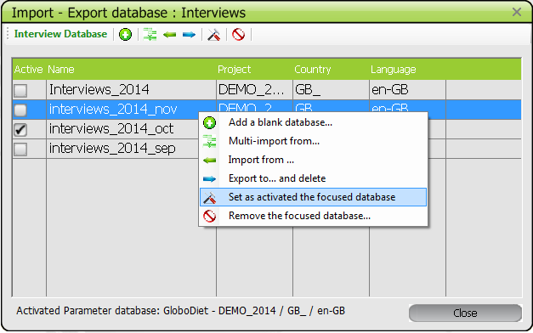

Using The Edit function of GloboDiet, you can have a look at all the imported interviews.
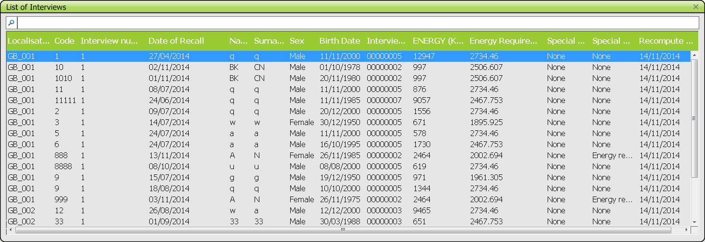

2.2.4 Export of interview databases
The function « Export to… », generates 3 different types of files, 1 BAK-file, 1 XML-file and 5 CSV-files of the active interview database. Once the export is done, the activated and exported interview database is suppressed from GloboDiet application.
You can export the selected set of interviews by clicking on the icon (in the tool bar or using the right mouse button).
A pop-up is displayed allowing selecting folder(s) in which to save the selected set of interviews. A BAK-file, a XML-file and 5 CSV-files will be generated and copied to this folder.
The user has to give one name (same name for the BAK and XML-file with two different extensions). The BAK & CSV-files can be exported to a different folder than the XML-file.
The user also has the option to have the current date added to the file name by checking the designated field. The 5 CSV-files are generated at the same time as the BAK-file and are:
- INTGI: File containing general information on subject and on recall/record.
- NOTES: File containing reported notes during the interview/data entry.
- INTERV: File containing reported foods/recipes/ingredients/supplements with detailed consumption descriptions.
- INTERV_QT: File containing two specific quantification methods that are photo and shape methods for which several servings can be selected.
Note: This file is not generated if these two methods have not been selected during the interview/data entry.
- INTNUT: File containing energy and macro-nutrient intakes per reported food. The available components are energy, proteins, fats, carbohydrates, alcohol and water.
Please, find in annex, the content of these 5 CSV-files.

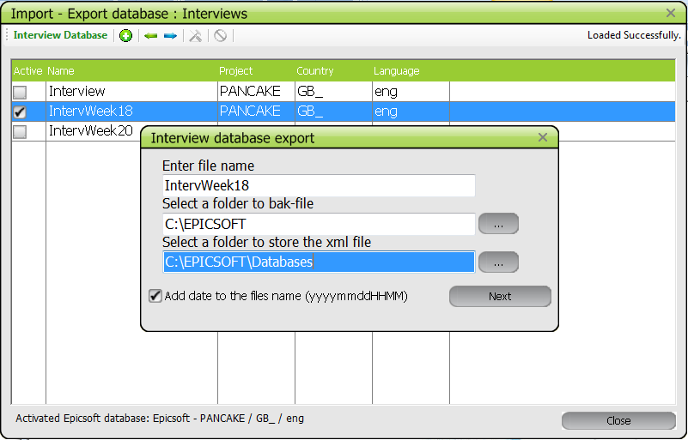
The export ends with the following confirmation message
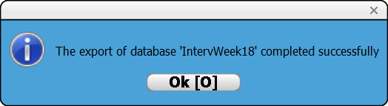

The exported interview database is no longer available in the interview database screen.
The first interview database in the list is now the active one. However, the user can activate another database (see point 1.1.3). Note that if no other interview database is available, a new and empty one is automatically created (called “Interview”) and activated.
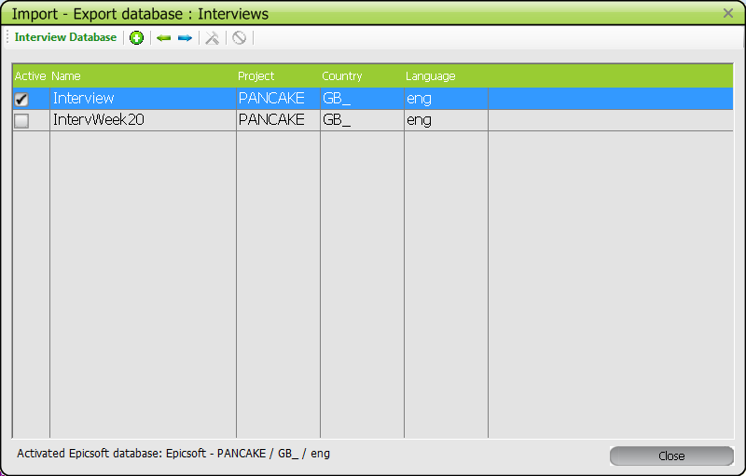

3. GloboDiet parameter database management

In the sub-menu of the GloboDiet Parameter Databases the parameter databases (defined by the coordinators of the study) for the GloboDiet application can be handled and two menu functions are accessible:
- « Restore Databases »
- « Import Databases »
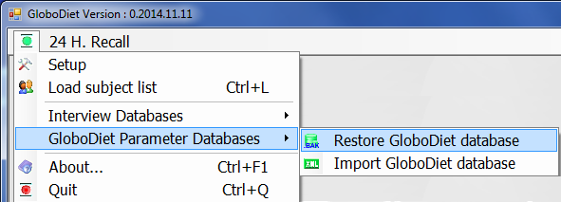

3.1 Restore GloboDiet database (BAK-file)
If you click on « Restore Databases », the following pop-up appears:
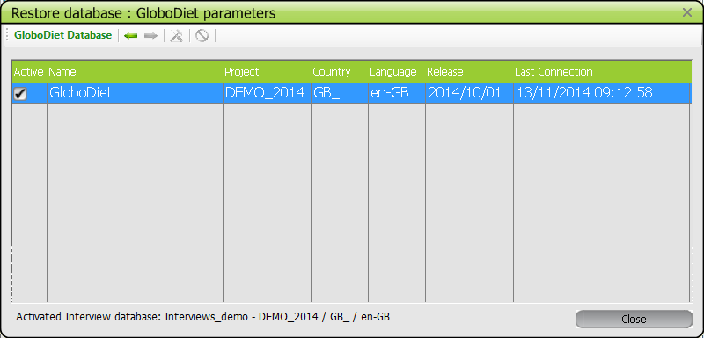
The active database is identified by the selected check box in front of the database name.
The ‘restore GloboDiet parameter’ function allows the user to load a parameter backup file (called BAK-file).
The main reasons to restore a GloboDiet BAK-file are:
- When you receive a new updated GloboDiet parameter database from IARC
- In case of a crash in the PC and you want to restore the last up-to-date GloboDiet parameter database on another PC.
You can import/restore the GloboDiet parameter database selecting the icon (in the tool bar or using the right mouse button).
A pop-up is displayed allowing to:
- Enter database name called “GloboDiet” by default
- Select a BAK-file within folders using the browse button
- Select the “Override if database exists” button if you want to keep the same GloboDiet database name and override the existing one.
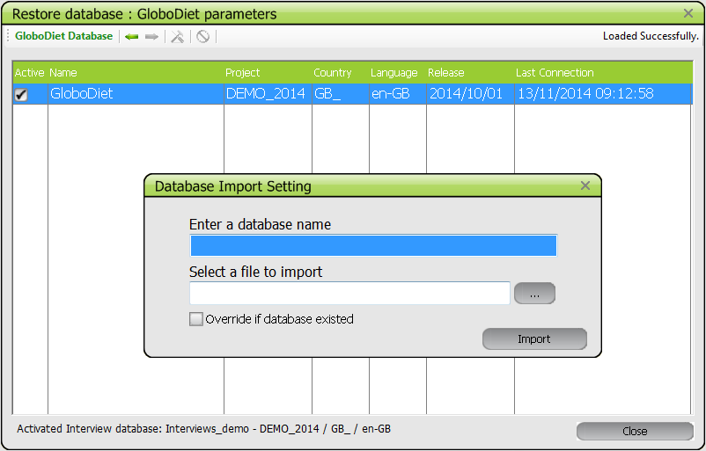
Once the correct information is entered, you can select the Import button.
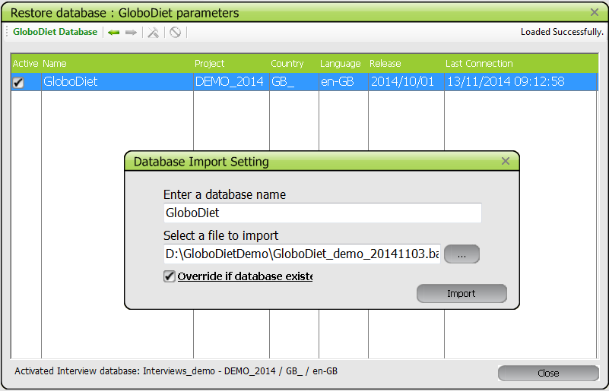

The import ends with the following message:
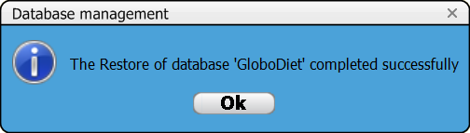
The Database management screen now contains the new database.

3.2 Import GloboDiet database (XML-files)
The ‘Import GloboDiet parameter’ function allows the user to load a parameter XML-file (called XML-file). This XML-file will be generated by the Maintenance and setting application (MSapp) that is under development. For this reason, it is not yet possible to use this function.
If you click on « Import GloboDiet Databases », the following pop-up appears:
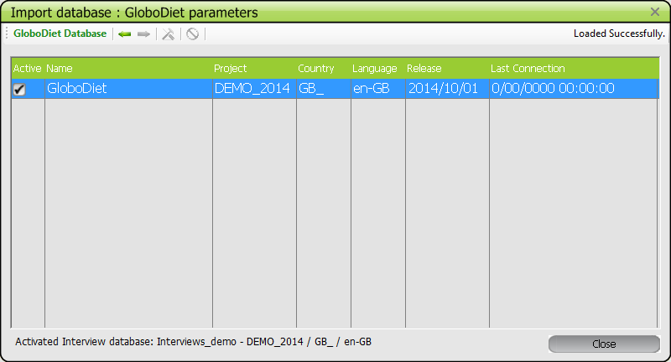
The active database is identified by the selected check box in front of the database name.

4. Management of GloboDiet CSV-files

4.1 How to merge CSV-files using a bat-file/program
The GloboDiet export generates the 5 following CSV-files (see above the definitions):
- InterviewSetName_INTGI_date.csv
- InterviewSetName_INTERV_date.csv
- InterviewSetName_INTER_QT_date.csv
- InterviewSetName_INTNUT_date.csv
- InterviewSetName_NOTES_date.csv
Each interviewer has to export and send the completed collected data to the coordinator(s). The coordinator may need to merge them in order to manage them (e.g. for the received Notes.csv files).
A way to do this is by using a bat-file where specific commands are used. This task requires some familiarity with Windows and although it can be done by anyone following carefully the bellow instructions, it may be done faster by a knowledgeable datamanager/statistician.
You can find here 2 examples on how to prepare this Merge_csv_file.bat.
Some explanations on the contents of the bat-file:
- A line starting with REM is a comment line
- The first commands are to define the folder where the CSV-files are and have to be revised according to your needs (highlighted in blue).
- The last commands are to merge the CSV-files in one
- The merged file should be a CSV-file too
- The string highlighted in blue (see below) can be adapted to you needs (e.g. folder name, merged file name)
Preparation of the bat-file:
- Open the Notepad application (available on most PCs)
- Select the commands of the first or second example from Start to the End lines, copy and paste them in Notepad
- Adapt the commands to your needs by changing the lables in highlited in blue
- Save the notepad file giving‘.bat’ as an extension (e.g. merge_csv.bat)
Running the bat-file:
- To run the bat-file, you just have to double click on it.
- A black pop-up is opened where the merged files are listed after each Copy command.
- To close this pop-up, you can type exit or use the cross at the top right of the window.
- If the merged files already exit and you run again the bat-file, these merged files will be replaced by the new ones so do not forget to save them in another folder.

Example 1: The merged CSV-files are available in the same folder as the other CSV-files
REM Start:
REM Merge of CSV-FILES – Generated files available in the same folder

REM Move to the folder
D:
cd d:\GD_data\Marina\

REM Merge of the CSV-files in 5 main ones

REM Use of 'COPY' command
REM - the star is used to select all the CSV-files containing the string
REM “INTGI__2014”
REM - the merged file names are defined in the right of the command
REM (e.g. INTGI_2014.csv)
REM - in this example, the new 5 created files will be stored in
REM the same folder as all the CSV-ones and here in d:\GD_data\Marina
COPY *INTGI__201*.csv INTGI_2014.csv
COPY *INTERV__201*.csv INTERV_2014.csv
COPY *INTERV_QT__201*.csv INTERV_QT_2014.csv
COPY *INTNUT__201*.csv INTNUT_2014.csv
COPY *NOTES__201*.csv NOTES_2014.csv
cmd
REM The end

Example 2: The merged CSV-files are moved in a sub-folder called Merge that is created during the process
REM Start
REM Merge of CSV-FILES put in Merge sub-folder
D:
cd d:\GD_data\Marina\

REM Creation of a sub-folder called Merge (e.g. d:\GD_data\Marina\Merge)
md Merge

REM Merge of the CSV-files in 5 main ones

REM Use of 'COPY' command
REM - the star * is used to select all the CSV-files containing the string “INTGI__2014”
REM - the merged file names are defined in the right of the command (e.g. INTGI_2014.csv)
REM - in this example, the new 5 created files will be stored in the already created folder
REM d:\GD_databases\Marina\Merge
COPY *INTGI__201*.csv Merge\INTGI_2014.csv
COPY *INTERV__201*.csv Merge\INTERV_2014.csv
COPY *INTERV_QT__201*.csv Merge\INTERV_QT_2014.csv
COPY *INTNUT__201*.csv Merge\INTNUT_2014.csv
COPY *NOTES__201*.csv Merge\NOTES_2014.csv

REM Remark: in place of the ‘Merge\’ folder, you can also specify the entire folder name as
REM COPY *INTGI__201*.csv \GD_data\Marina\Merge\INTGI_2014.csv

cmd
REM The end

4.2 How to open CSV-files using Excel functionalities

We can always open a CSV-file with excel by clicking directly on the file but, in this case, some format information can be lost as well as special characters (e.g. accents…).

It is for this reason that we recommend to use the functions of Excel called “Data” & “From Text”:

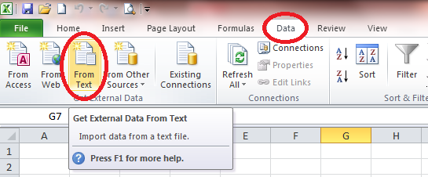

Once you have selected this function, Excel asks you to select a CSV-file in your folder.
For example, here, the Notes file dated from 30 April 2014 of interviewer called Marina:
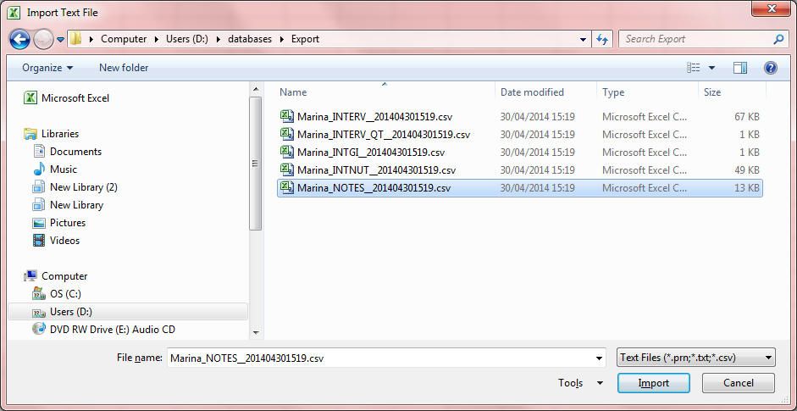

Then Excel asks you to select a data type between 2; Delimited or Fixed and also to select a File origin.
For the GloboDiet CSV-files, you have to select:
- Delimited as data type
- Unicode (UTF-8) as origin (strongly recommended)
You can then select the “Next” button.
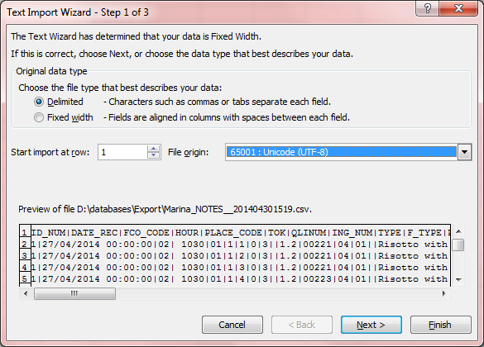

The next pop-up is related to the file format. You have to define the delimiter and the format of each column.
For the GloboDiet CSV-files, you have to select ‘Other’ and type the pipe (‘|’) character as delimiter.
Then, you can select the “Next” button.

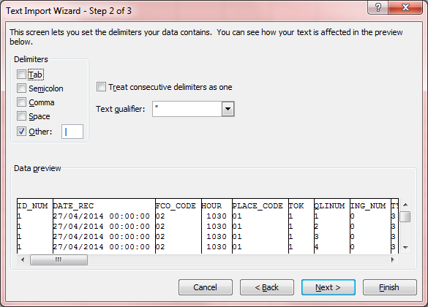

For each column, the format has to be specified. You can select all the columns at once by clicking on the first column, then move to the last one and while holding theShift key + click on the last column with the mouse at the same time.
For the Notes file, you can declare all the columns as Text except for the CONS_QTY one that is General format.
- See guideline Appendix 7 Example_SAS_programs_GloboDiet_Export.docx to transform the 5 CSV- files in SAS databases.

- See the document Appendix 6 – Formats of exported data.doc to have the detailed formats of all the GloboDiet Export CSV-files as the possible values (and labels) for each column.

Then, you can select the “Finish” button.
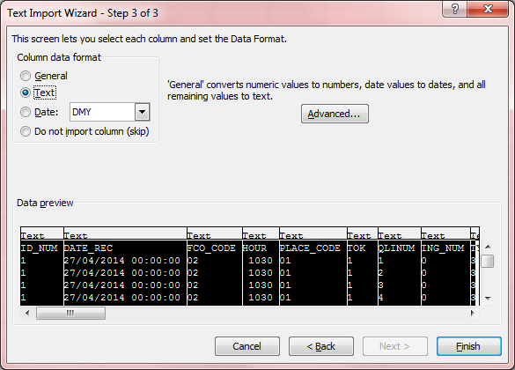
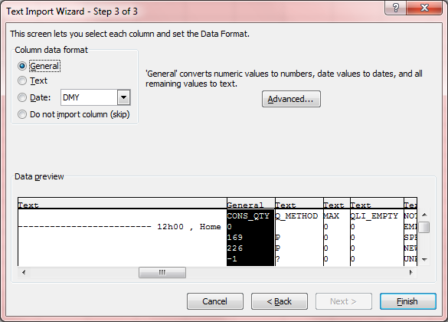

The last question is related to where the data will be placed in the worksheet and usually the cell A1 (top – left) is pre-selected. By clicking on OK button, the data are displayed in the Excel sheet.

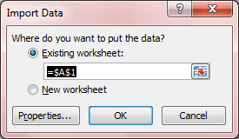

Example with the Notes file:
The first few columns of the Notes file worksheet are specify the subject codes (column A in blue below) & interview dates (column B below), followed by information on the reported items such as the FCO (column C below), Type (column I below) and item label (column P in blue below).

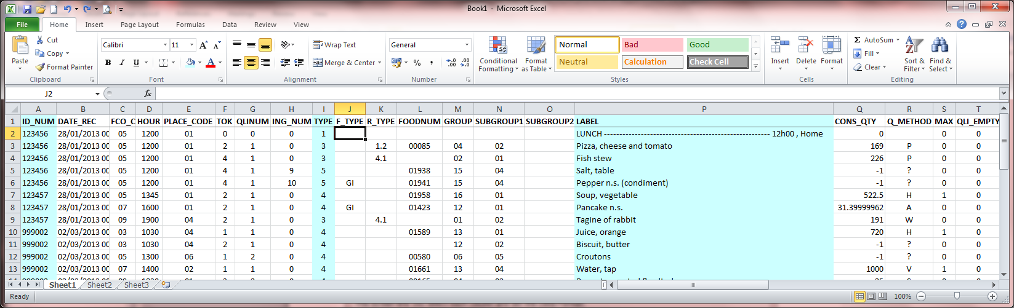

To the right of the worksheet, you can see the information related to the reported Notes such as the code for the note type, status, the reported comments (column W below) and the date of the last comments entered (column X below).

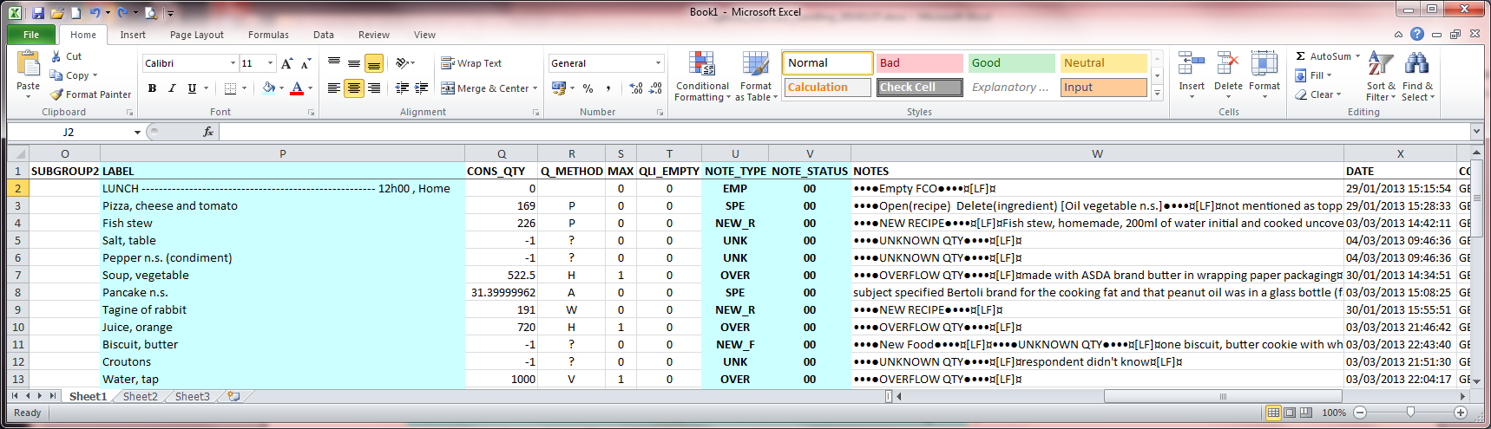

Note: the characters “¤[LF]¤” in the Notes column, is the paragraph mark used by GloboDiet application.

4.3 Formats of the GloboDiet exported CSV-files
- See guideline Appendix 6 Export_guideline_v4.docx to have the format of the 5 generated CSV-files

4.4 Example on how to import the GloboDiet CSV-files using SAS program
- See guideline Appendix 7 Example_SAS_programs_GloboDiet_Export.docx to transform the 5 CSV- files in SAS databases.

